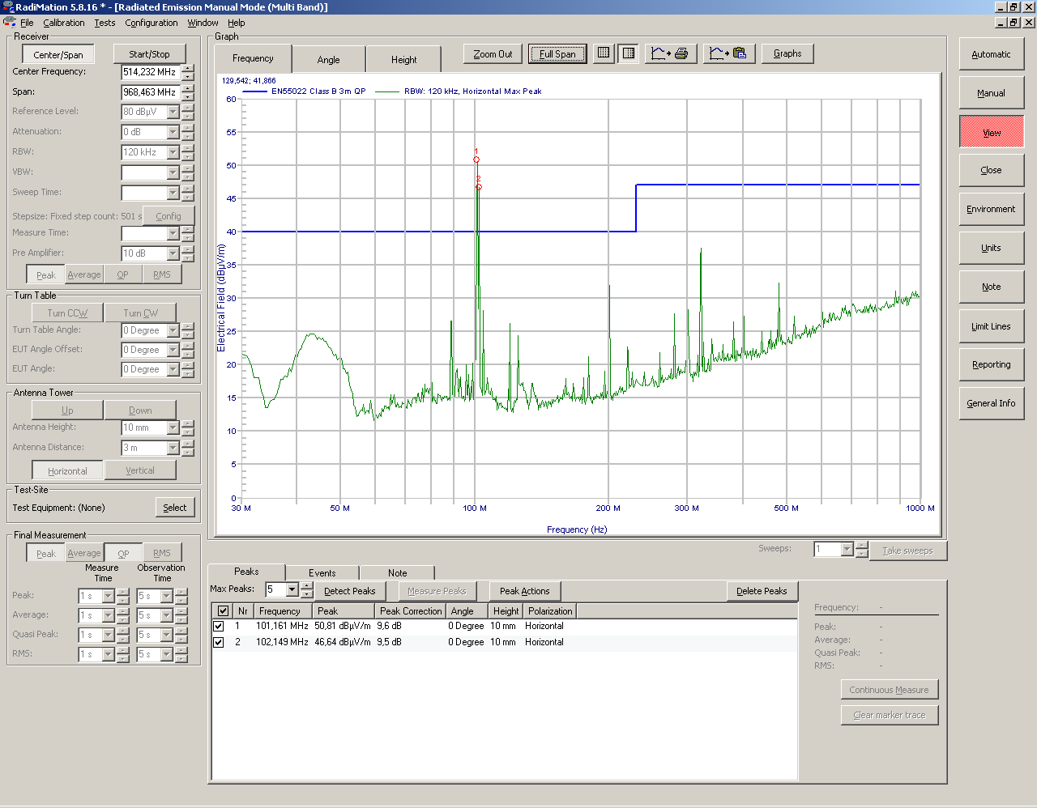
Meting 3: 200 MHz nu wel zichtbaar!
Print out plot meting 3.
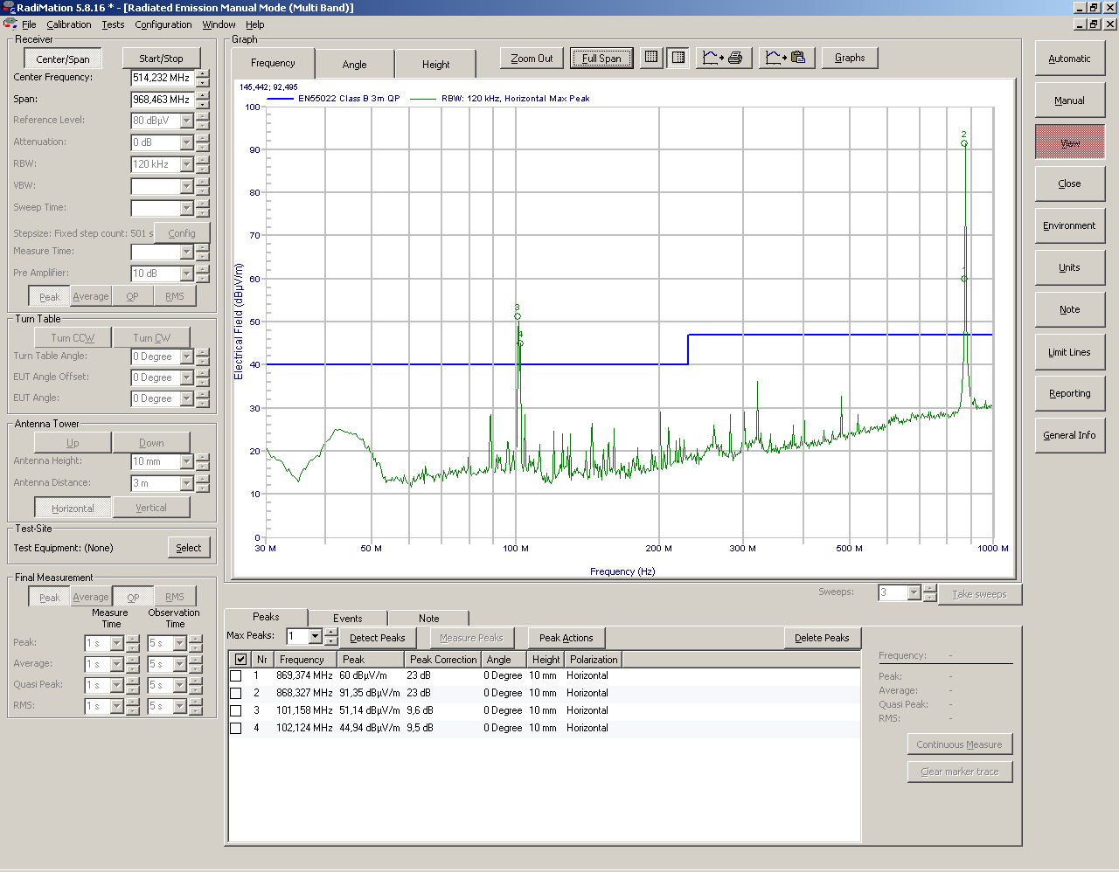
Meting 4
Print out in pdf meting 4.

