Radiated Emission Multiband ReportGenerator Codes

 | Description | Code ||~Code|| | Output band 1 | Output band 2
1 | Frequencies Start | ||~Frequencies Start|| | ||Band 1 Frequencies Start|| | ||Band 2 Frequencies Start||
2 | Frequencies End | ||~Frequencies End|| | ||Band 1 Frequencies End|| | ||Band 2 Frequencies End||
3 | Reference level | ||~Reference level|| | ||Band 1 Reference level|| | ||Band 2 Reference level||
4 | Attenuation | ||~Attenuation|| | ||Band 1 Attenuation|| | ||Band 2 Attenuation||
5 | RBW | ||~RBW|| | ||Band 1 RBW|| | ||Band 2 RBW||
6 | VBW | ||~VBW|| | ||Band 1 VBW|| | ||Band 2 VBW||
7 | Sweeptime | ||~Sweeptime|| | ||Band 1 Sweeptime|| | ||Band 2 Sweeptime||
8 | Frequency Stepper Fixed Step | ||~Frequency Stepper Fixed Step|| | ||Band 1 Frequency Stepper Fixed Step|| | ||Band 2 Frequency Stepper Fixed Step||
9 | Frequency Stepper StepType | ||~Frequency Stepper StepType|| | ||Band 1 Frequency Stepper StepType|| | ||Band 2 Frequency Stepper StepType||
10 | Measure time | ||~Measure time|| | ||Band 1 Measure time|| | ||Band 2 Measure time||
11 | Preamplification | ||~Preamplification|| | ||Band 1 Preamplification|| | ||Band 2 Preamplification||
12 | Number of sweeps | ||~Number of sweeps|| | ||Band 1 Number of sweeps|| | ||Band 2 Number of sweeps||
13 | Testsite Name | ||~Testsite Name|| | ||Band 1 Testsite Name|| | ||Band 2 Testsite Name||
14 | LocationTypeText | ||~LocationTypeText|| | ||Band 1 LocationTypeText|| | ||Band 2 LocationTypeText||
15 | Antenna movement Highest height | ||~Antenna movement Highest height|| | ||Band 1 Antenna movement Highest height|| | ||Band 2 Antenna movement Highest height||
16 | Antenna movement Lowest height | ||~Antenna movement Lowest height|| | ||Band 1 Antenna movement Lowest height|| | ||Band 2 Antenna movement Lowest height||
17 | Antenna movement Number of heights | ||~Antenna movement Number of heights|| | ||Band 1 Antenna movement Number of heights|| | ||Band 2 Antenna movement Number of heights||
18 | Antenna movement Mode | ||~Antenna movement Mode|| | ||Band 1 Antenna movement Mode|| | ||Band 2 Antenna movement Mode||
19 | Antenna distance | ||~Antenna distance|| | ||Band 1 Antenna distance|| | ||Band 2 Antenna distance||
20 | Antenna distance | ||~Antenna distance|| | ||Band 1 Antenna distance|| | ||Band 2 Antenna distance||
21 | Antenna polarization | ||~Antenna polarization|| | ||Band 1 Antenna polarization|| | ||Band 2 Antenna polarization||
22 | Turntable movement Start angle | ||~Turntable movement Start angle|| | ||Band 1 Turntable movement Start angle|| | ||Band 2 Turntable movement Start angle||
23 | Turntable movement End angle | ||~Turntable movement End angle|| | ||Band 1 Turntable movement End angle|| | ||Band 2 Turntable movement End angle||
24 | Turntable movement Number of angles | ||~Turntable movement Number of angles|| | ||Band 1 Turntable movement Number of angles|| | ||Band 2 Turntable movement Number of angles||
25 | Turntable movement Mode | ||~Turntable movement Mode|| | ||Band 1 Turntable movement Mode|| | ||Band 2 Turntable movement Mode||
26 | EUT angle offset | ||~EUT angle offset|| | ||Band 1 EUT angle offset|| | ||Band 2 EUT angle offset||
27 | Limitline Description | ||~Limitline Description|| | ||Band 1 Limitline Description|| | ||Band 2 Limitline Description||
28 | Limitline Peak | ||~Limitline Peak|| | ||Band 1 Limitline Peak|| | ||Band 2 Limitline Peak||
29 | Limitline Average | ||~Limitline Average|| | ||Band 1 Limitline Average|| | ||Band 2 Limitline Average||
30 | Limitline Quasi peak | ||~Limitline Quasi peak|| | ||Band 1 Limitline Quasi peak|| | ||Band 2 Limitline Quasi peak||
31 | Limitline RMS | ||~Limitline RMS|| | ||Band 1 Limitline RMS|| | ||Band 2 Limitline RMS||
32 | Above Limit | ||~Above Limit|| | ||Band 1 Above Limit|| | ||Band 2 Above Limit||
33 | Number of peaks | ||~Number of peaks|| | ||Band 1 Number of peaks|| | ||Band 2 Number of peaks||
34 | Peak discrimination | ||~Peak discrimination|| | ||Band 1 Peak discrimination|| | ||Band 2 Peak discrimination||

Band 1 | Band 2
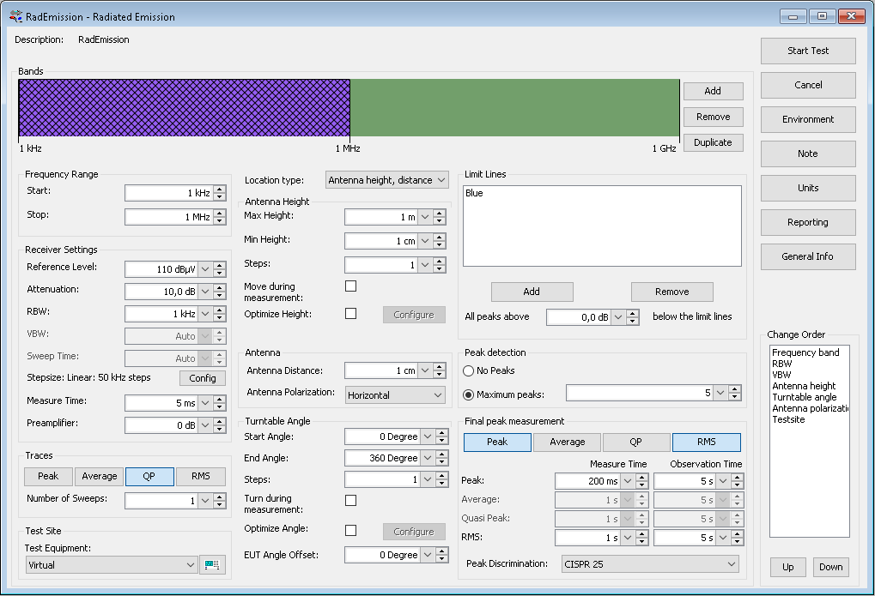 | 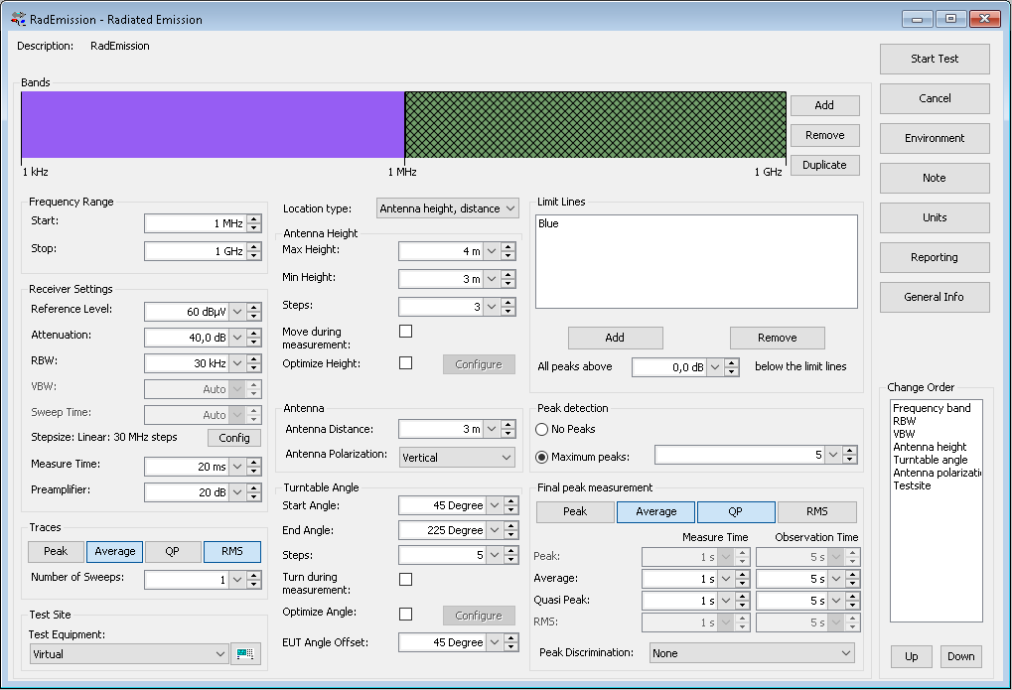
Limitline Limitline Table Band1  ||~Band 1 Limitline Description|| | Band 2 Limitline Limitline Table  ||~Band 2 Limitline Description||
  ||~Band 1 Limitline Limitline Table||
  ||~Band 2 Limitline Limitline Table||
||Band 1 Limitline Description|| | ||Band 2 Limitline Description||
  ||Band 1 Limitline Limitline Table||
  ||Band 2 Limitline Limitline Table||

