Radiated Emission Multiband ReportGenerator Codes

 | Description | Code ||~Code|| | Output band 1 | Output band 2
1 | Frequencies Start | ||~Frequencies Start|| | 1 MHz | 1 kHz
2 | Frequencies End | ||~Frequencies End|| | 1 GHz | 1 MHz
3 | Reference level | ||~Reference level|| | 60 dBµV | 110 dBµV
4 | Attenuation | ||~Attenuation|| | 40,0 dB | 10,0 dB
5 | RBW | ||~RBW|| | 30 kHz | 1 kHz
6 | VBW | ||~VBW|| | Auto [120 kHz] | Auto [120 kHz]
7 | Sweeptime | ||~Sweeptime|| | Auto [120 ms] | Auto [120 ms]
8 | Frequency Stepper Fixed Step | ||~Frequency Stepper Fixed Step|| | 30 MHz | 50 kHz
9 | Frequency Stepper StepType | ||~Frequency Stepper StepType|| | Linear | Linear
10 | Measure time | ||~Measure time|| | 20 ms | 5 ms
11 | Preamplification | ||~Preamplification|| | 20 dB | 0 dB
12 | Number of sweeps | ||~Number of sweeps|| | 1 | 1
13 | Testsite Name | ||~Testsite Name|| | Virtual | Virtual
14 | LocationTypeText | ||~LocationTypeText|| | Antenna height, distance, polarization and angle | Antenna height, distance, polarization and angle
15 | Antenna movement Highest height | ||~Antenna movement Highest height|| | 4 m | 1 m
16 | Antenna movement Lowest height | ||~Antenna movement Lowest height|| | 3 m | 1 cm
17 | Antenna movement Number of heights | ||~Antenna movement Number of heights|| | 3 | 1
18 | Antenna movement Mode | ||~Antenna movement Mode|| | Stepped | Stepped
19 | Antenna distance | ||~Antenna distance|| | 3 m | 1 cm
20 | Antenna distance | ||~Antenna distance|| | 3 m | 1 cm
21 | Antenna polarization | ||~Antenna polarization|| | Vertical | Horizontal
22 | Turntable movement Start angle | ||~Turntable movement Start angle|| | 45 Degree | 0 Degree
23 | Turntable movement End angle | ||~Turntable movement End angle|| | 225 Degree | 360 Degree
24 | Turntable movement Number of angles | ||~Turntable movement Number of angles|| | 5 | 1
25 | Turntable movement Mode | ||~Turntable movement Mode|| | Stepped | Stepped
26 | EUT angle offset | ||~EUT angle offset|| | 45 Degree | 0 Degree
27 | Limitline Description | ||~Limitline Description|| | Blue | Blue
28 | Limitline Peak | ||~Limitline Peak|| | True | True
29 | Limitline Average | ||~Limitline Average|| | True | True
30 | Limitline Quasi peak | ||~Limitline Quasi peak|| | True | True
31 | Limitline RMS | ||~Limitline RMS|| | True | True
32 | Above Limit | ||~Above Limit|| | 0,0 dB | 0,0 dB
33 | Number of peaks | ||~Number of peaks|| | 5 | 5
34 | Peak discrimination | ||~Peak discrimination|| | Undefined | CISPR 25

Band 1 | Band 2
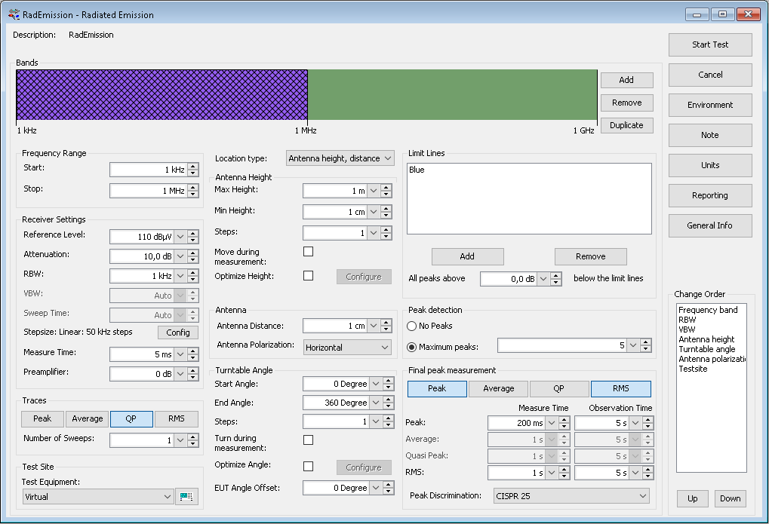 | 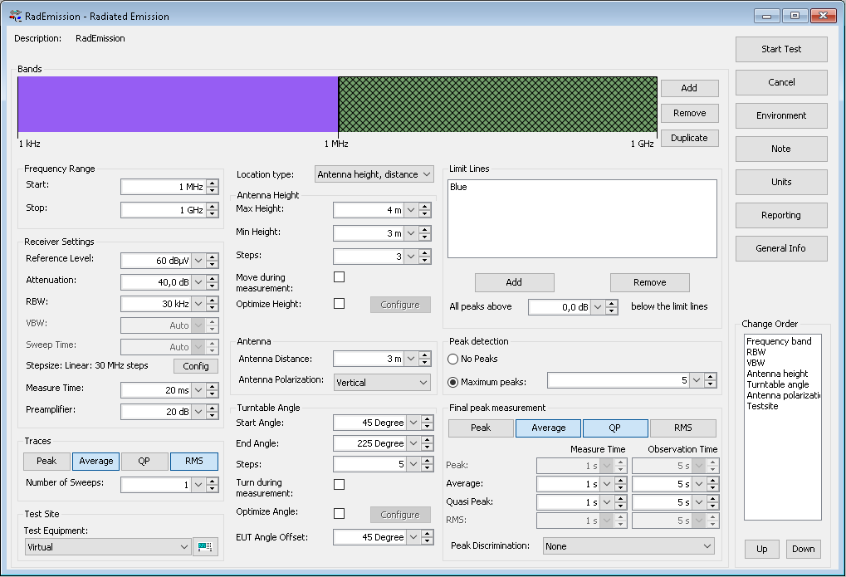
Limitline Limitline Table Band1  ||~Band 1 Limitline Description|| | Band 2 Limitline Limitline Table  ||~Band 2 Limitline Description||
  ||~Band 1 Limitline Limitline Table||
  ||~Band 2 Limitline Limitline Table||
Blue | Blue
  Frequency | Value
  1 | 100
  300 | 100
  300 | 150
  400 | 100
  500 | 100
  Frequency | Value
  1 | 100
  300 | 100
  300 | 150
  400 | 100
  500 | 100

